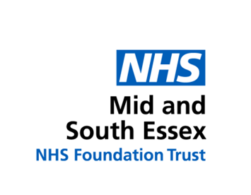
Decisions about treatment should be made on an individual basis and in consultation with families, taking into account my usual health. Decisions about my treatment and resuscitation should not be made based on my learning disability or autism or the Clinical Frailty Scale.
COVID-19 Learning Disability
Hospital Summary

 | Name |  |  |  |  |  | Address
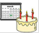 | Date Of Birth
 | Keeping me safe (any risks or behaviours that hospital staff need to know)
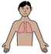 | Breathing issues  (e.g. asthma, history of respiratory infections) |  |  |  | If I have a new cough, when did it start? |  |  |  |  | If I have a temperature when did it start?
 |  | What support would I need to have a swab taken? |  |  | Have I had any change in skin colour? |  |  |  |  | Have I had contact with a person with a new cough or fever?
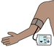 |  | Physical observations (what support would I need to have my blood pressure and temperature checked)
 |  |  | Someone who knows me well (this should be someone that we can talk to about your care and treatment) |  |  |  |  | Things that I like or would distract me if I am upset
Name:

Relationship:

Telephone number:
The Covid -19 summary sheet gives the information that doctors and nurses will need if you go to hospital because of COVID-19

It is not a replacement for the everyday, detailed hospital passport. You
should update your hospital passport and take that to hospital along with the
Grab and Go guide if you need to be admitted.
If you haven’t got a hospital passport you can download your local passport by
searching on the internet for (hospital name) hospital passport
If you need help completing the form please ask:
• someone who knows you well like a family member or support worker
• a social worker
• a support group you are in touch with
The most common symptoms of coronavirus (COVID-19) are:
 |  |  | a new, continuous cough
 |  |  | a high temperature (37.8 degrees and above)

If you have symptoms of coronavirus and need medical advice, 111
Do not go to places like a GP surgery,
pharmacy or hospital
Use the NHS 111 coronavirus service.

